Logistics Discussion

* Adam, Colin, Jason

Currently working on:

* Rig board – job board data alignment
  + Including loaded / on location
  + Auto-Loaded is waiting on work from BPAVS, BPAVS integration not planned yet.
* Backhaul functionality
  + Click on rig bin, “Rig Board” page
  + How to show back haul on job board page…..
* MTS printing online
  + Allowing the printing of the MTS at any point of the process with updated truck/crew info. Reschedule will also update information
* Testing in ~ 1 week (Feb 6 ish)

Future Desires:

* Would like to do most of the functionality in a single place – Job board is the preference
* Feeling like we are bouncing around to different pages to do different items. Makes it feel complicated

Bulk plant page

* Would like this page to be reworked. It is too busy and complicated
* Do not need to see the scheduled blends
* Do not want to move blends to the bin – do this automatically
* Once a blend is completed please move it to the bin
  + Have some logic to make sure that the bin is empty
  + If product is in there, stop the process and deal with product in the bin
* **Current Bulk Plant Page - GP:**

* **Desired Bulk Plant Page - GP:**

This is Colin’s desire, but it loses the view of conflicts if exists. E.g. there was 0:1:0 ‘G’ left in the bin from previous request. We are going to load ECOPrime from the next request, we want to avoid over topping by mistake. We will need to show what is currently in the bin and what is going to be loaded.

When we provide API for BPAVS, it will stop BPAVS loading to a bin if a different blend is in the Bin.

I would propose as following.

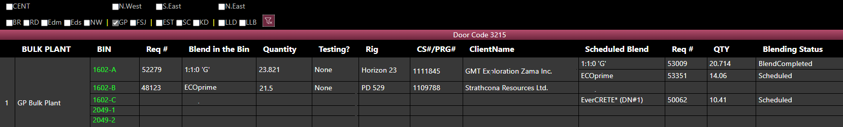

* Only show completed blends and have them put into the bin right away
  + Continue to show all the associated information for the blend in the bin

~~Create Load~~Haul Blend – options for different call sheet…

* Currently call sheets are available that match the base blend
  + Concerns that this could cause an error if people are not paying attention and select only the first call sheet in the list
  + View above will keep call sheet #’s visible
* If call sheet which the blend request was originated is not complete, keep the same call sheet.
* If call sheet is complete, manually enter
  + Have validation on exact blend match (blend + dry blended additives)

Notes (DRB - Bulker Job Board)

* Need larger area for more notes
* Currently Use Notes for:
  + Non rig haul
  + Raw product
  + Convoy only
  + Resting
  + Resetting
  + Save for another job

Raw product haul

* Vendor to BP
* BP to BP
* Want 2 options with clean view
  + Right click on bulk plant
    - Time
    - Vendor
    - Roduct
    - Crew
    - PO
    - Other
* Right click on Bulk Plant on the Bulk Plant page:



* When clicking on “Vendor to BP”

* BP to BP

Aside: Off duty timer not working when a haul is pending – Jason to test this.

It should be integration issue. In latest version of DRB, DRB only sends status change request to eServiceOnline, eServiceOnline side may not reset the timer properly.